
Student Name: Kenan Kiplimo
Admission Number: BSCCS/2025/67071
Course/Class: Bachelor of Science in Computer science
Unit Code: BIT4138
Unit Name: Advanced Cryptography
Lecturer Name: Mr. Michael Nyoro
Semester/Academic Year: Year 3 Semester 2, May 2026

Selected Technologies:
- ParrotOS Security
- VSCodium
- Python

GitHub: https://github.com/Kynan51/advanced-cryptography

Week 1: Cryptography Environment Setup 2
Fig 1: Installation of Codium 3
Fig 2: Installation of Cryptography Libraries 3
Fig 3: OpenSSL Installation Test 4
Fig 4: Local Encryption Script Execution 4
Fig 5: GitHub Repository Initialization 5
Student Reflection 5
Week 2: Classical Cryptography and Cipher Design 7
Fig 1: Caesar Cipher Implementation 7
Fig 2: Vigenère Cipher Encryption Process 7
Fig 3: Encryption and Decryption Output 8
Fig 4: User Input Validation Interface 8
Fig 5: Cipher Testing Results 9
Student Reflection 9
Week 3: Stream Ciphers and Randomness Testing 10
Fig 1: LFSR Generator Implementation 11
Fig 2: Pseudorandom Sequence Output 11
Fig 3: Statistical Randomness Testing 11
Fig 4: RC4 Stream Cipher Simulation 12
Fig 5: Encryption Performance Results 12
Student Reflection 13
Week 4: Block Cipher Design and AES 13
Fig 1: AES Encryption Script 13
Fig 2: Key Generation Process 14
Fig 3: File Encryption Demonstration 14
Fig 4: Decryption Results 15
Fig 5: AES Performance Testing 15
Student Reflection 16
Week 5: Public Key Cryptography (RSA) 16
Fig 1: RSA Key Pair Generation 17
Fig 2: Public Key Encryption Process 17
Fig 3: Private Key Decryption Results 18
Fig 4: Secure Message Transmission 18
Fig 5: RSA Testing and Validation 19
Student Reflection 19
Week 6: Hashing and Password Security 20
Fig 1: SHA-256 Hash Generation 21
Fig 2: Password Hashing System 21
Fig 3: Login Authentication Workflow 21
Fig 4: Hash Verification Results 22
Fig 5: Password Security Testing 22
Student Reflection 23

Week 1: Cryptography Environment Setup
Installation and Configuration of Cryptography Development Environment

Fig 1: Installation of VSCodium
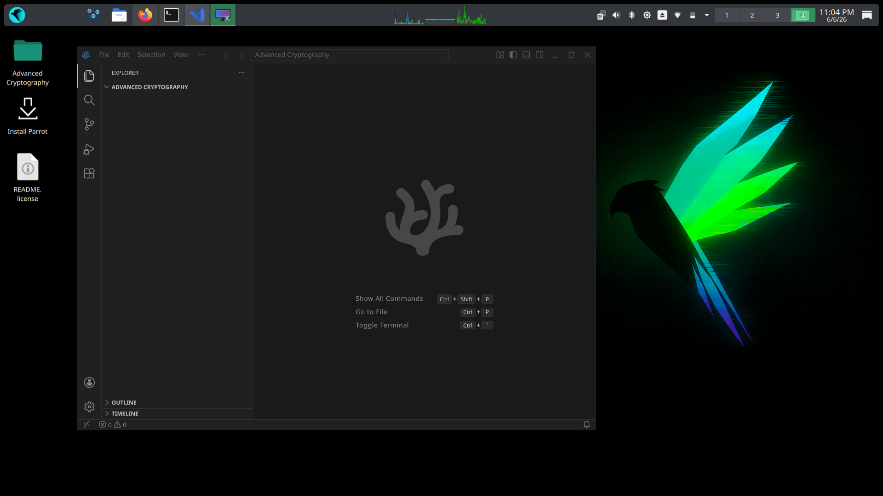

Fig 2: Installation of Cryptography Libraries
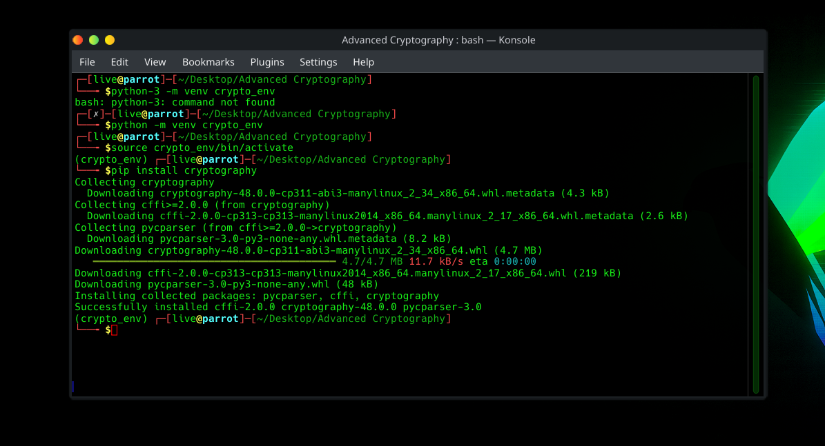

Fig 3: OpenSSL Installation Test
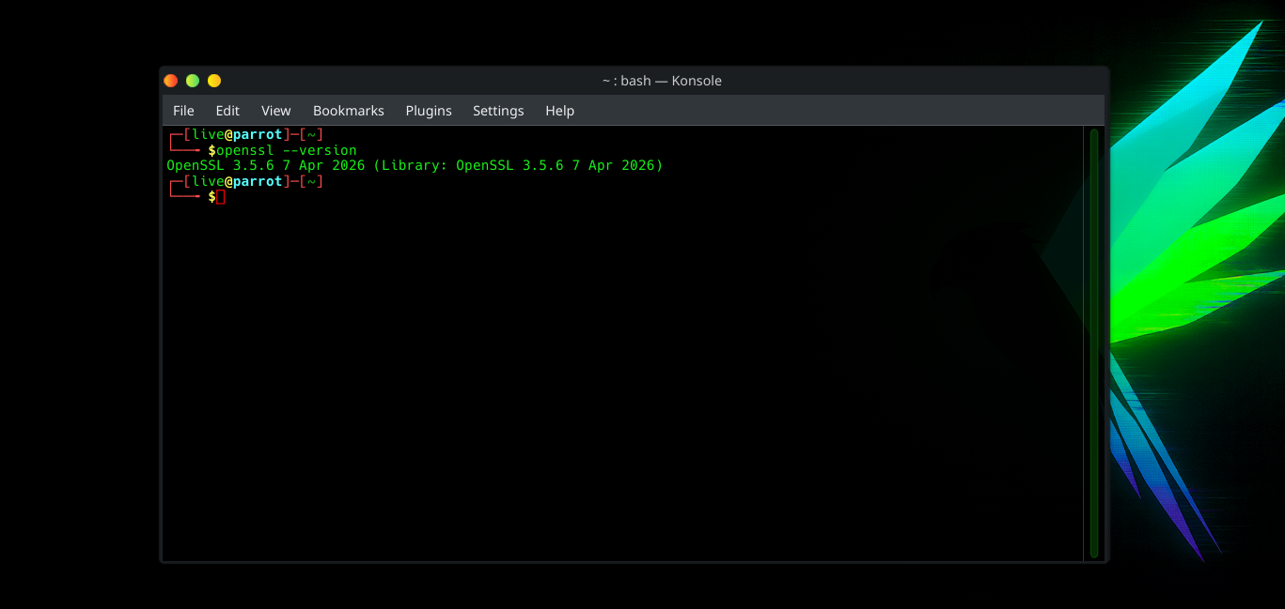

Fig 4: Local Encryption Script Execution
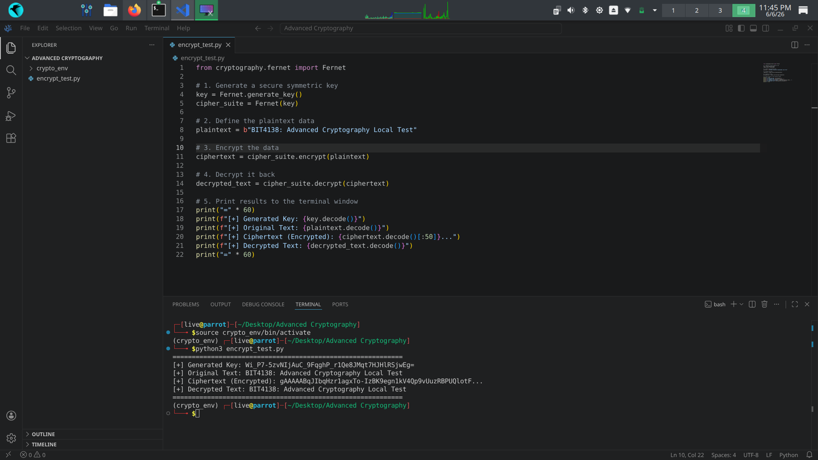

Fig 5: GitHub Repository Initialization
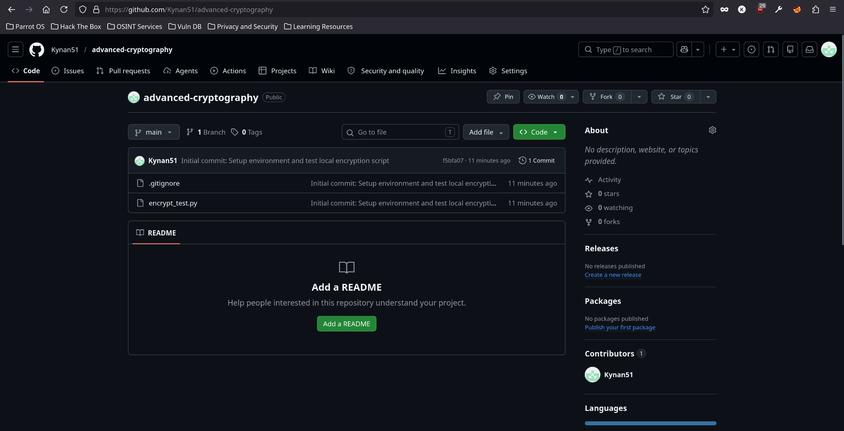

Student Reflection
Configured a portable development environment on a live persistent Parrot OS workstation. Verified the pre-installed OpenSSL architecture and established secure version control via Git. Fig 3 confirms successful installation and configuration of OpenSSL used for generating secure cryptographic keys and certificates.

Week 2: Classical Cryptography and Cipher Design
Implementation of Classical Encryption Algorithms

Fig 1: Caesar Cipher Implementation
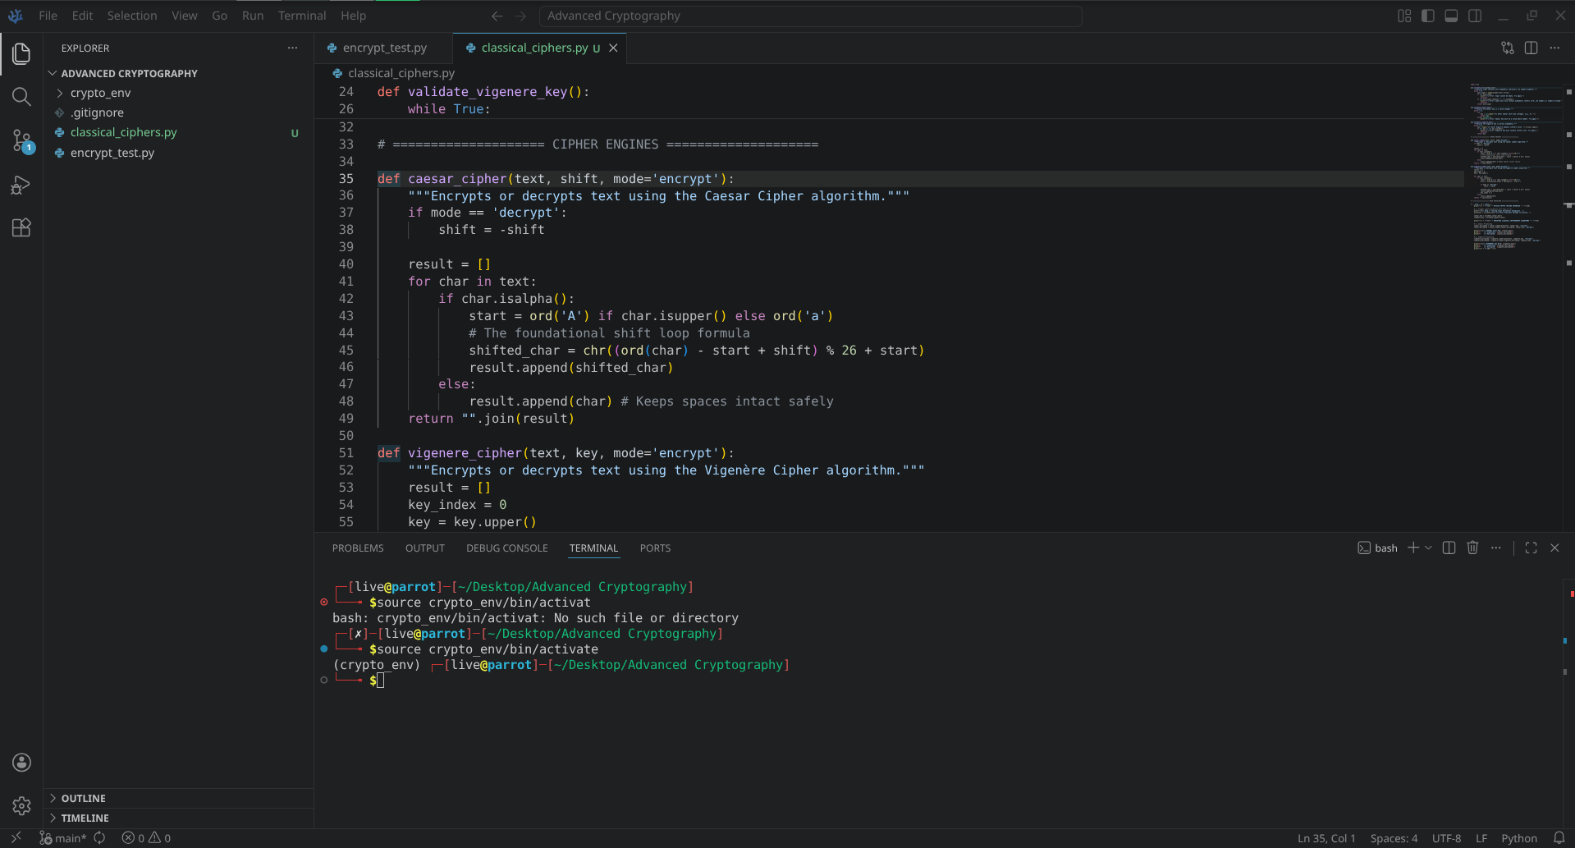

Fig 2: Vigenère Cipher Encryption Process
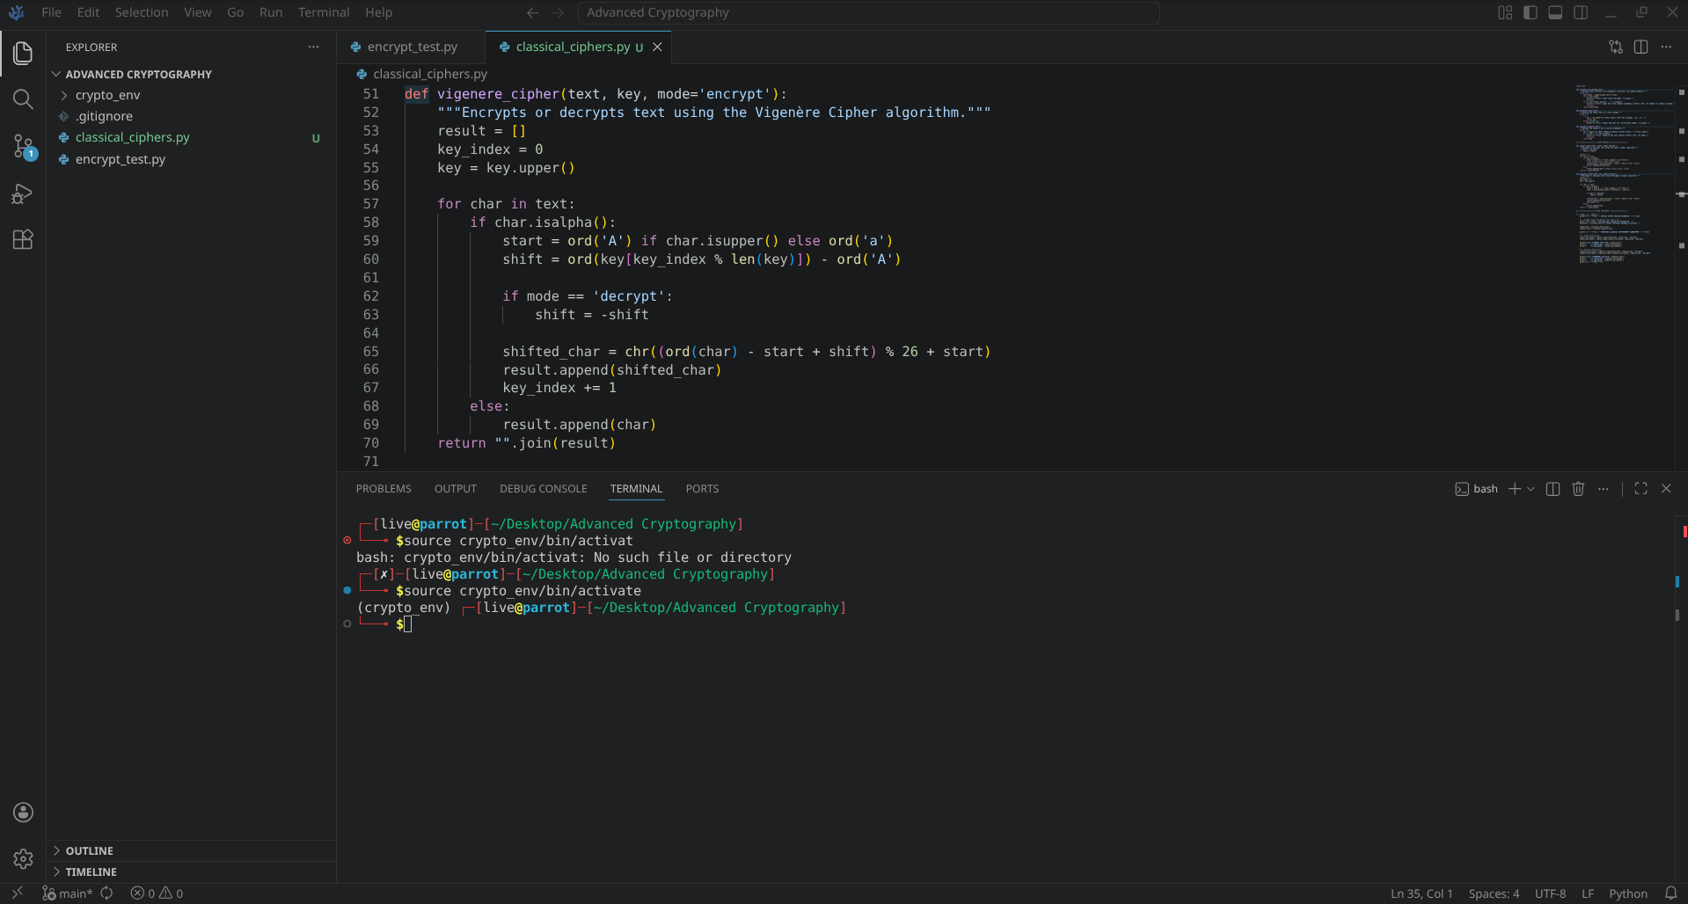

Fig 3: Encryption and Decryption Output
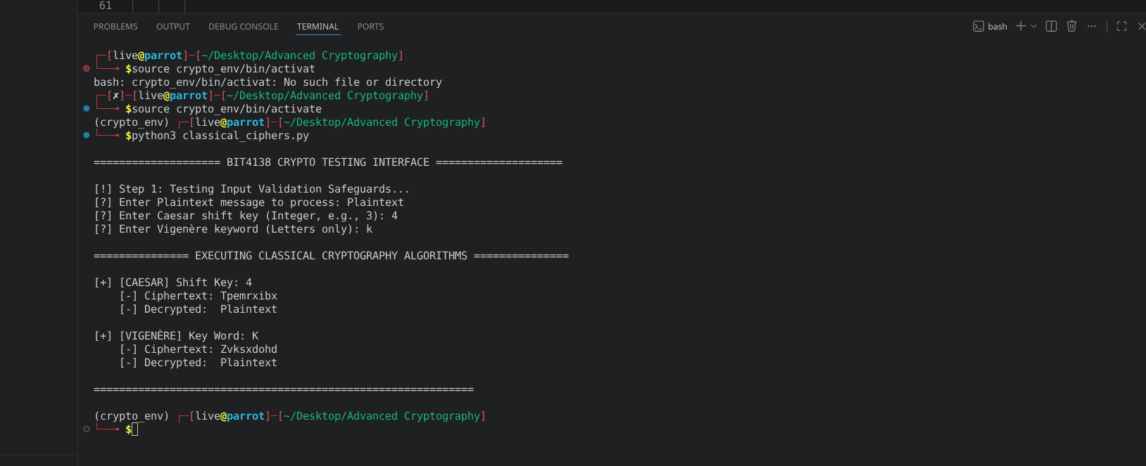

Fig 4: User Input Validation Interface
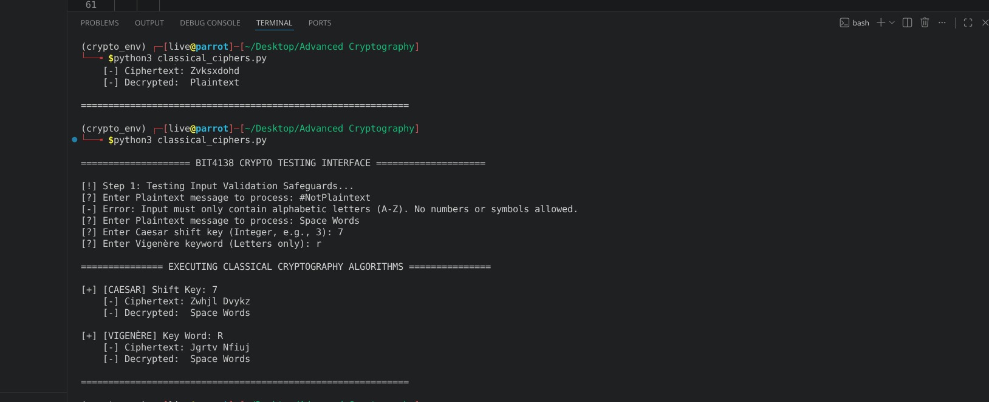

Fig 5: Cipher Testing Results

Student Reflection
Implemented functional Caesar and Vigenère polyalphabetic cipher architectures inside Parrot OS to analyze traditional data transformation rules. Developed input sanitization checks to handle structured data constraints defensively. The Vigenère implementation successfully demonstrated how using a variable alphabet rotation counter flattens pattern distributions to mitigate basic statistical frequency cryptanalysis vulnerabilities

Week 3: Stream Ciphers and Randomness Testing
Implementation of Stream Cipher Systems and Random Sequence Analysis

Fig 1: LFSR Generator Implementation
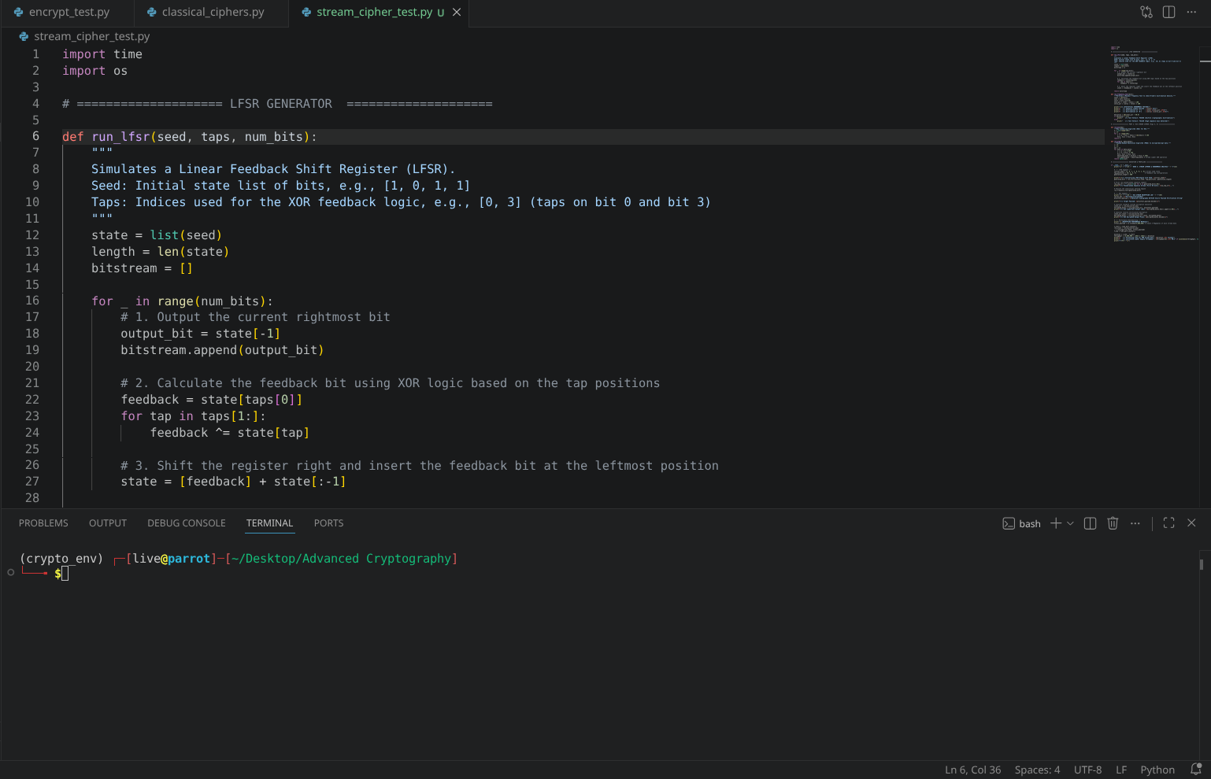

Fig 2: Pseudorandom Sequence Output
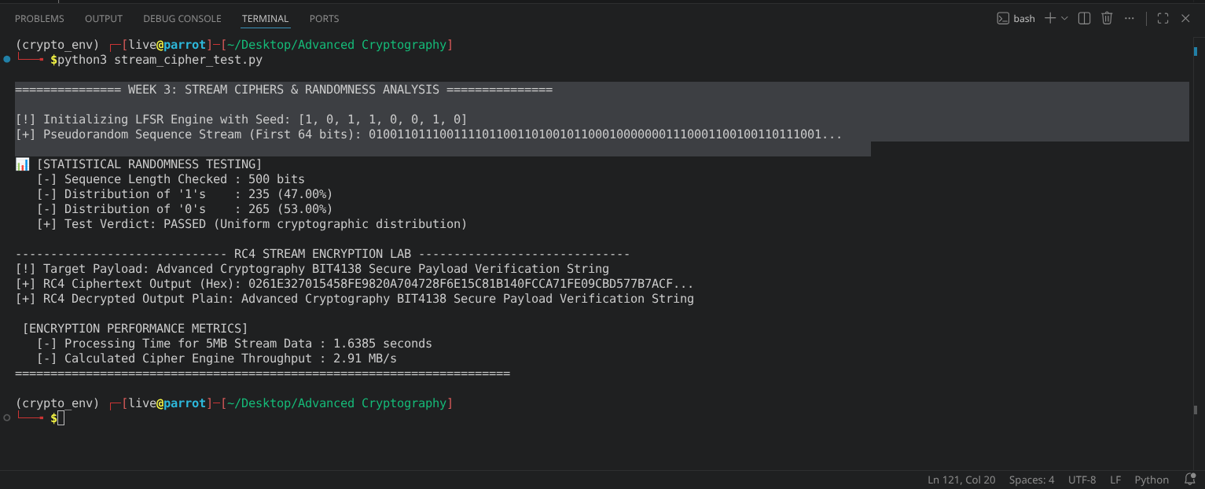

Fig 3: Statistical Randomness Testing
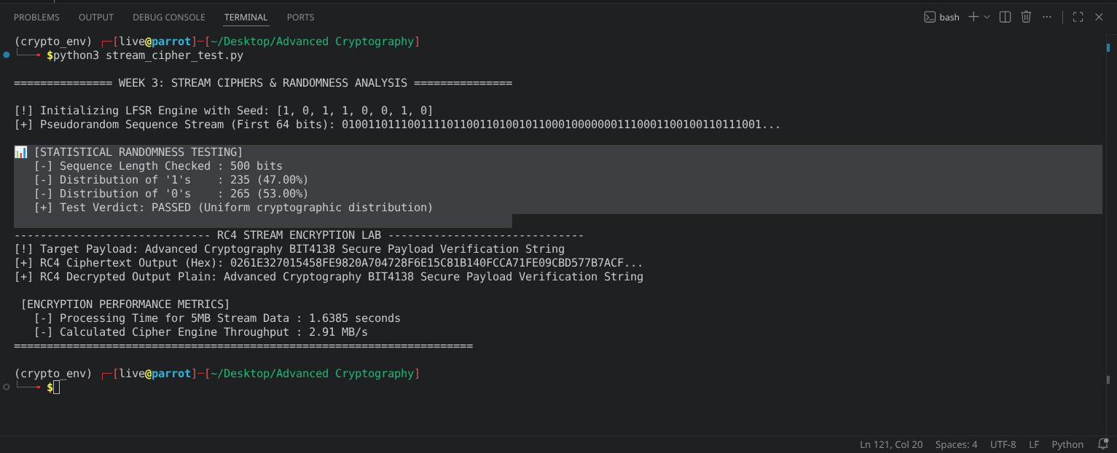

Fig 4: RC4 Stream Cipher Simulation
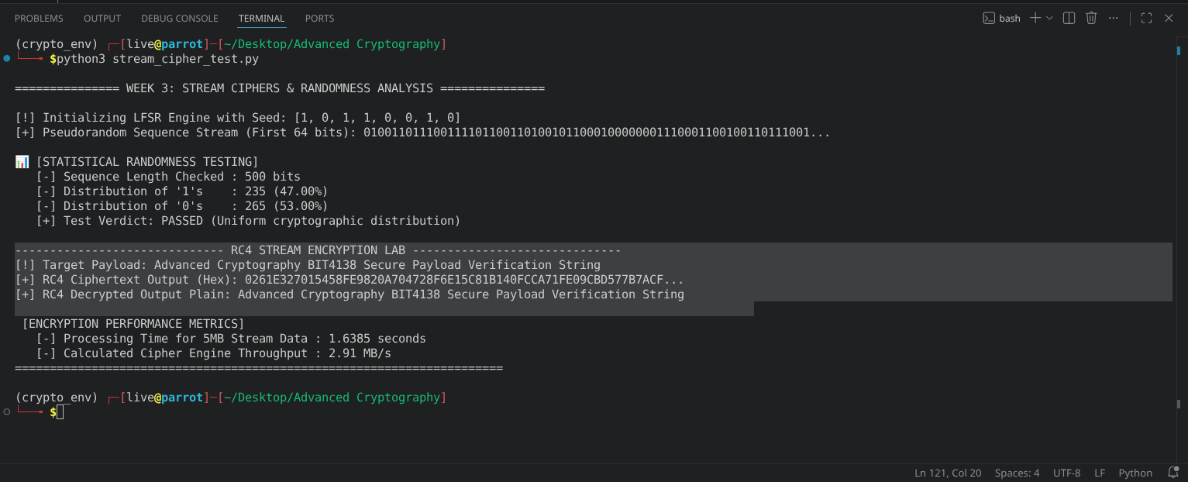

Fig 5: Encryption Performance Results
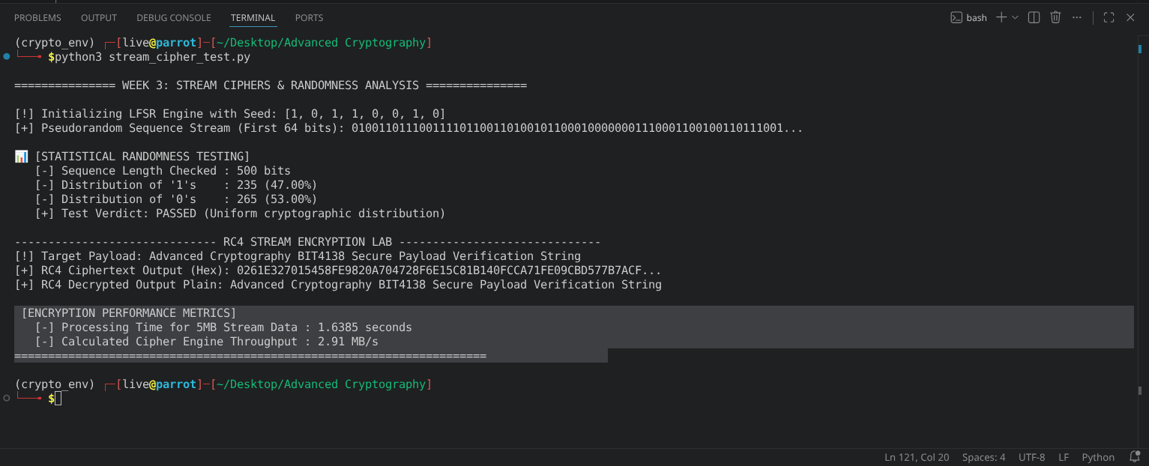

Student Reflection
Simulated an LFSR and RC4 engine to examine continuous byte-level encryption. Cryptographic randomness creates unpredictable key streams to defend against plaintext structural recognition. Executed monobit statistical testing to verify uniform distribution balance, confirming that high-speed throughput and low latency are successfully achieved without introducing mathematical sequence patterns.

Week 4: Block Cipher Design and AES
Advanced Encryption Standard (AES) and Block Cipher Operations

Fig 1: AES Encryption Script
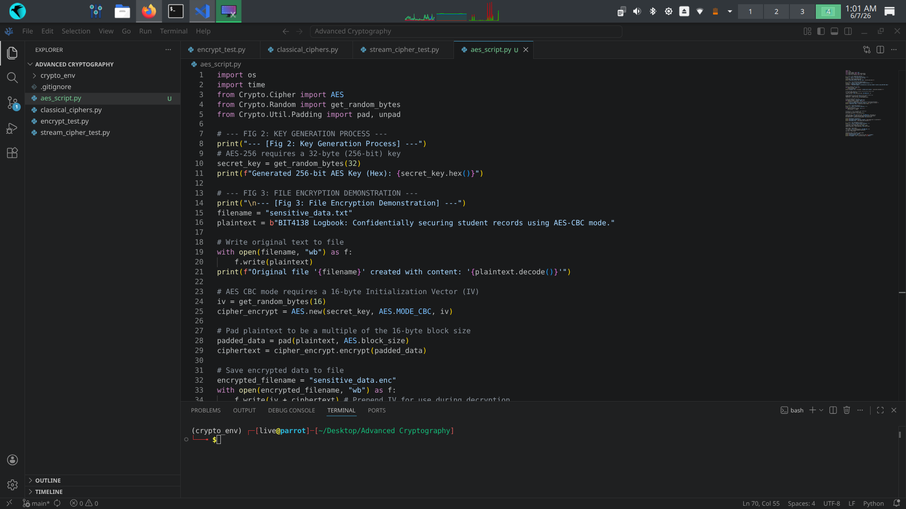

Fig 2: Key Generation Process
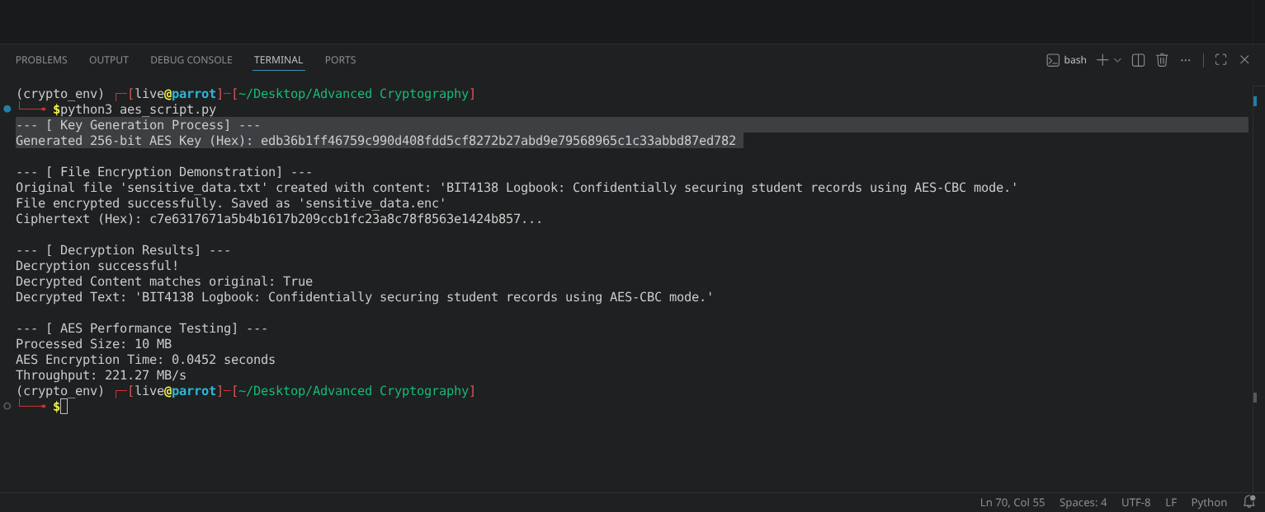

Fig 3: File Encryption Demonstration
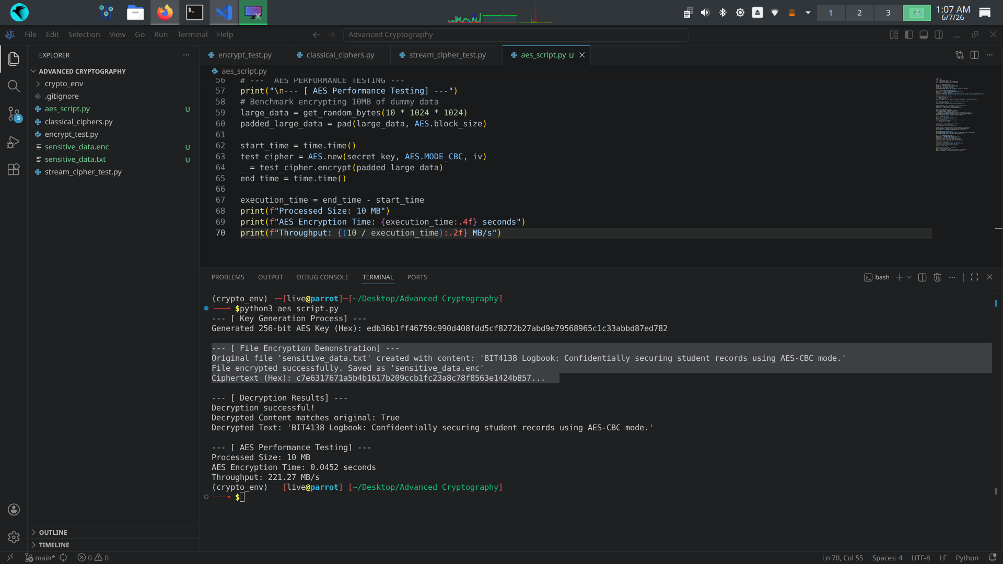

Fig 4: Decryption Results
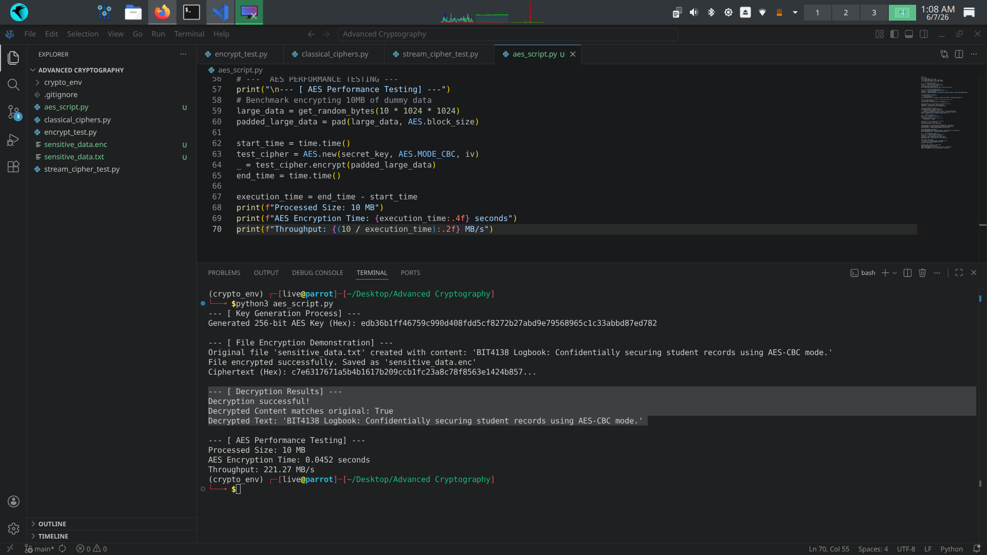

Fig 5: AES Performance Testing
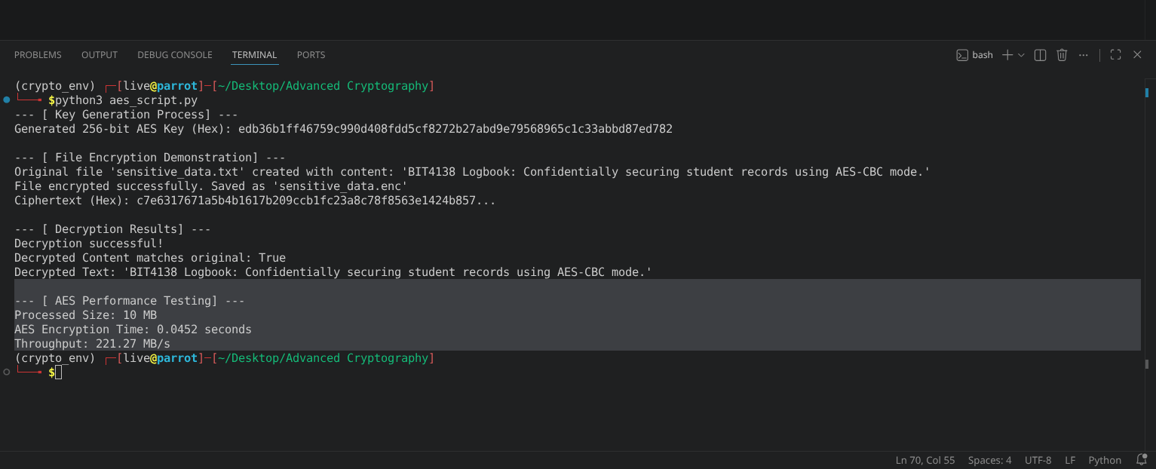

Student Reflection
Implemented AES-256 in CBC mode, mastering its block-by-block diffusion workflow. Correctly padding data and securely handling the initialization vector (IV) was challenging. Secure key management proved vital, as compromised keys invalidate the entire encryption/decryption integrity. Performance testing highlighted AES’s exceptional, hardware-optimized computational efficiency with large files.

Week 5: Public Key Cryptography (RSA)
Implementation of RSA Encryption and Key Management

Fig 1: RSA Key Pair Generation
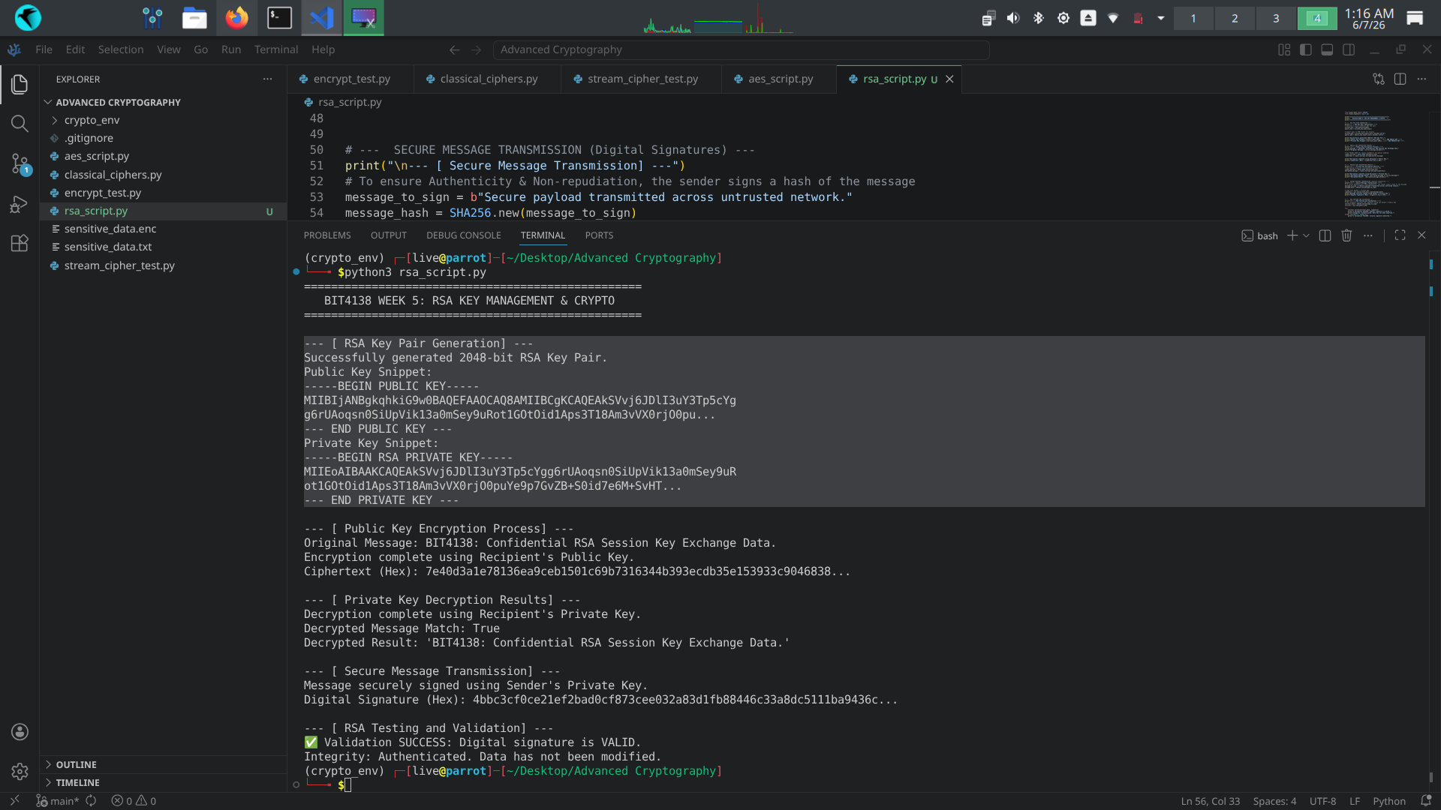

Fig 2: Public Key Encryption Process
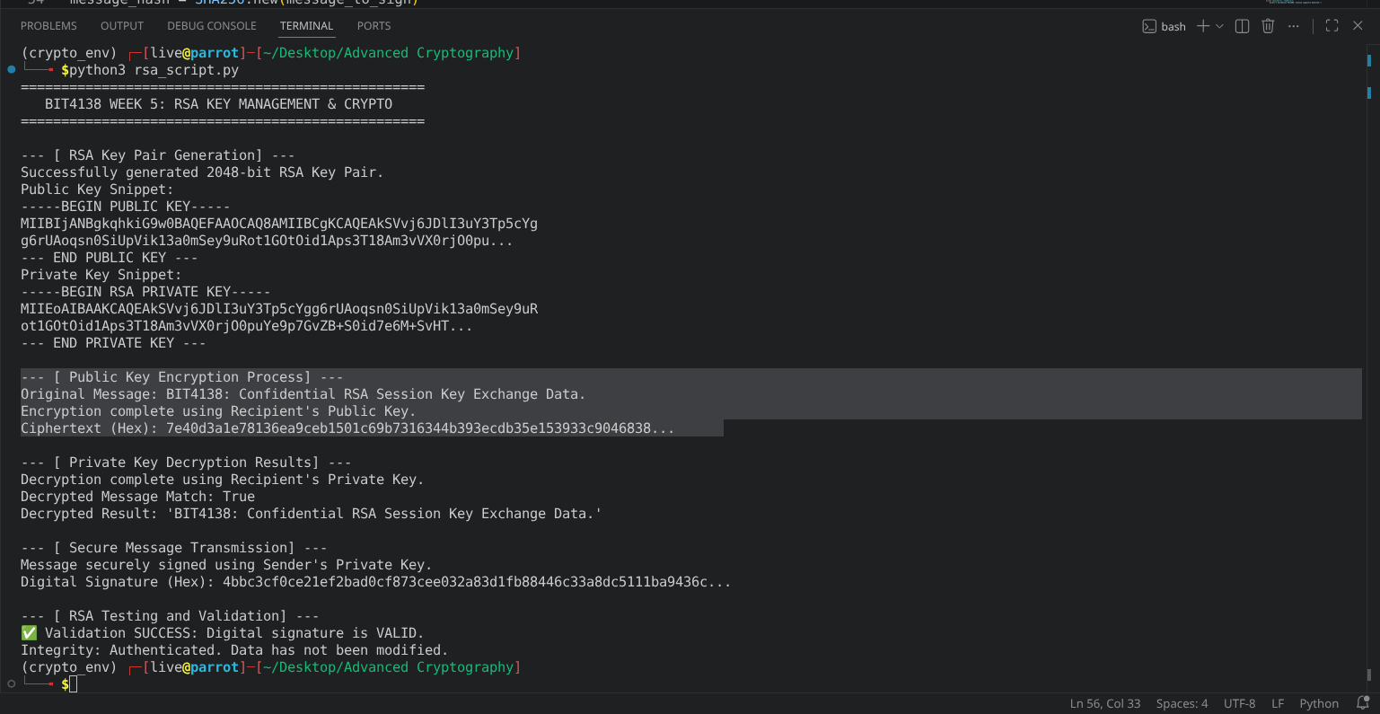

Fig 3: Private Key Decryption Results
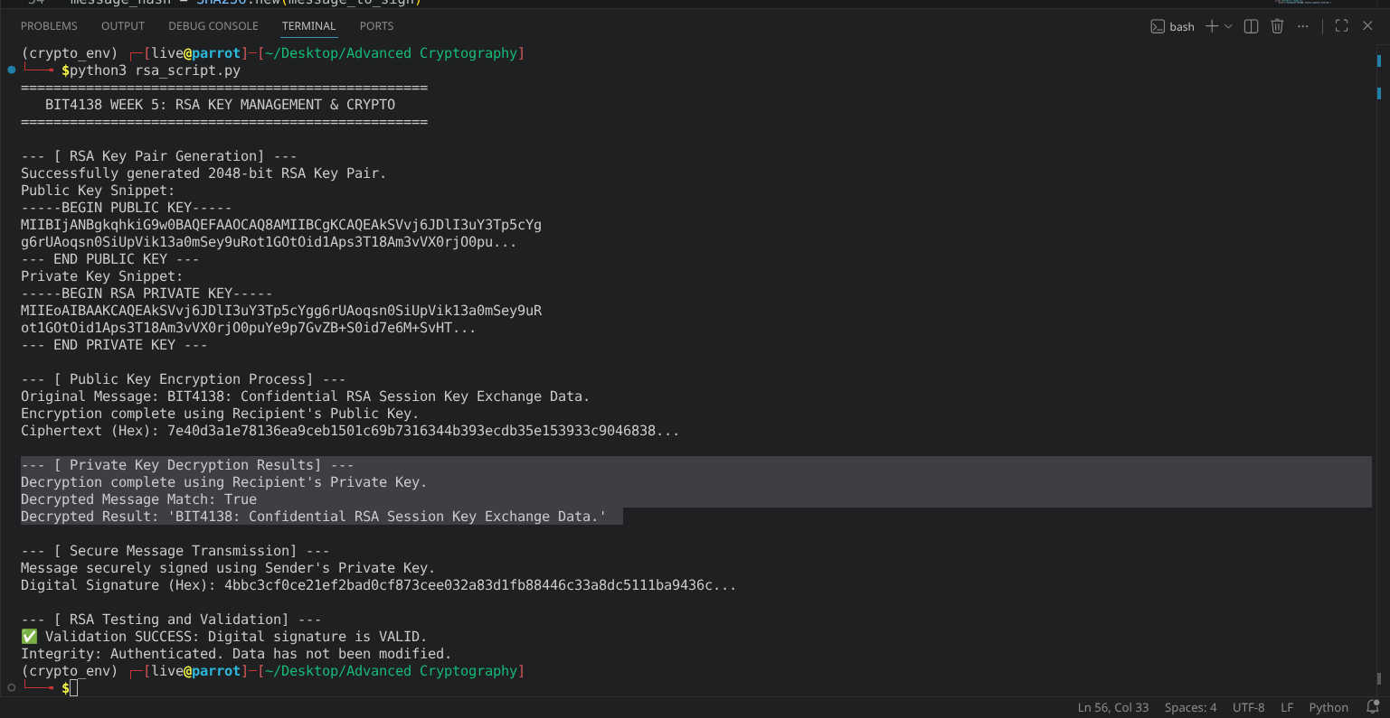

Fig 4: Secure Message Transmission
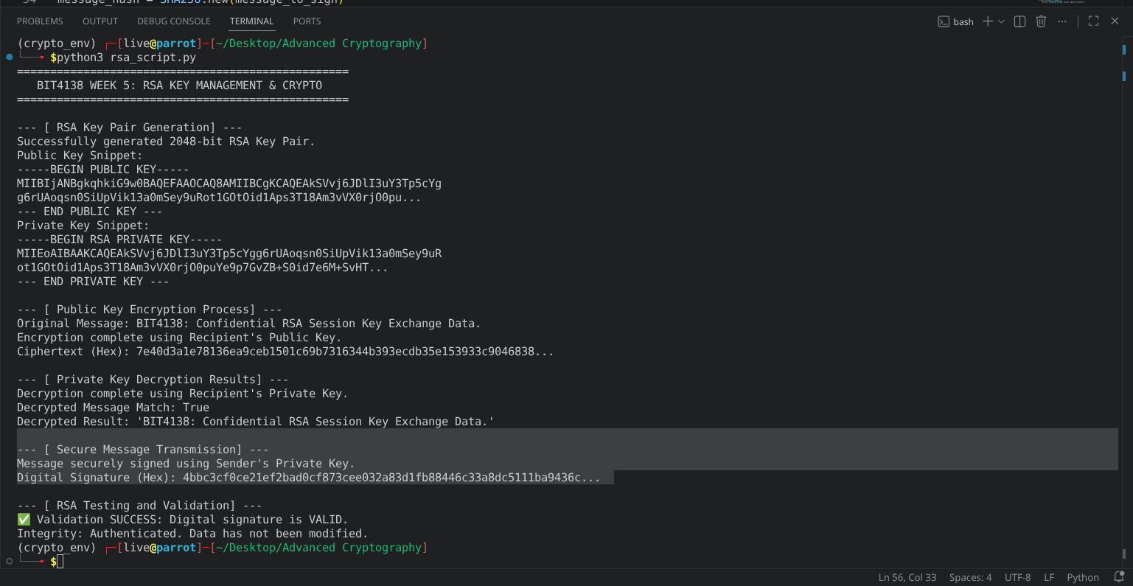

Fig 5: RSA Testing and Validation
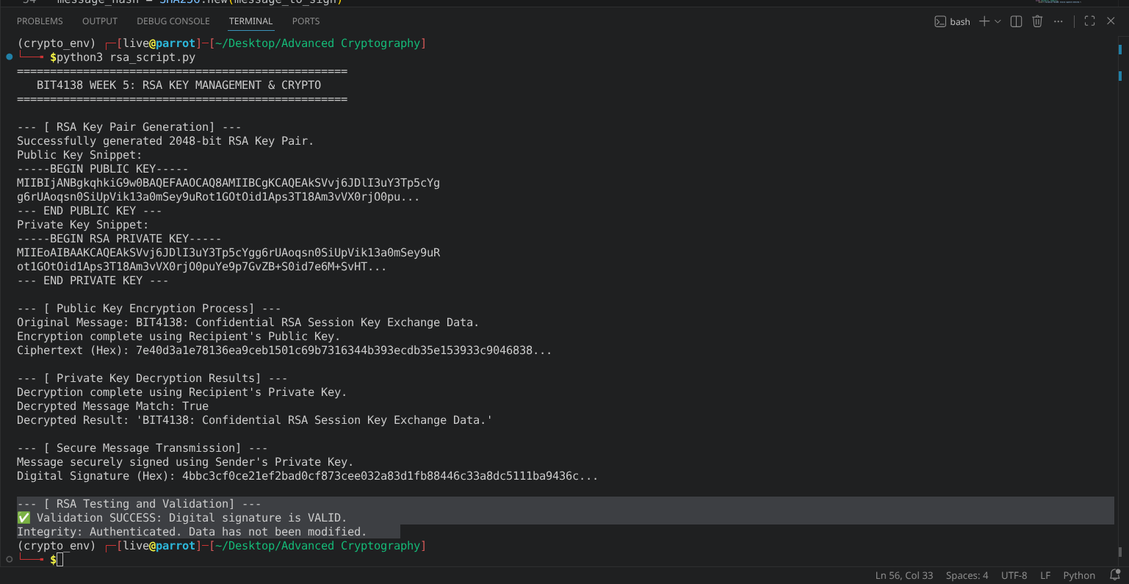

Student Reflection
Configured an asymmetric 2048-bit RSA key pair to evaluate public-key infrastructure. I leveraged the public key for data encryption and digital signature verification, while reserving the private key for decryption. Managing mathematical overhead and ensuring signature validation padding configurations were challenging, yet the process perfectly underscored core message integrity mechanisms.

Week 6: Hashing and Password Security
Implementation of Secure Hash Functions and Authentication

Fig 1: SHA-256 Hash Generation
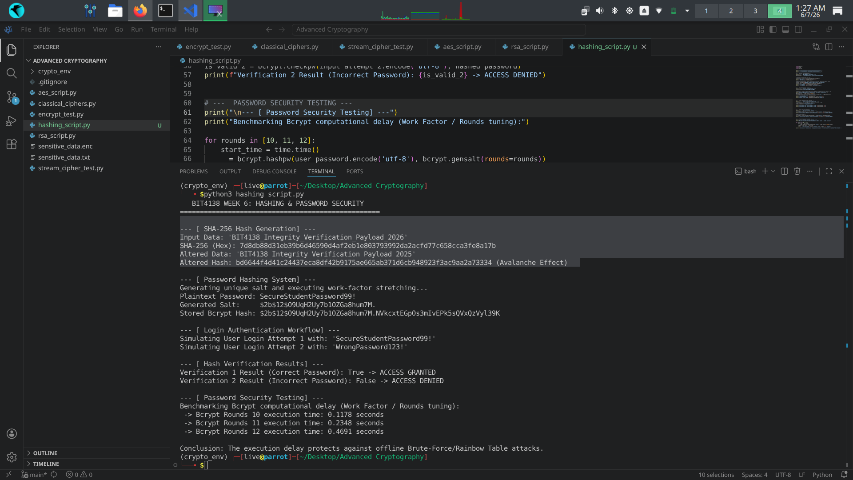

Fig 2: Password Hashing System
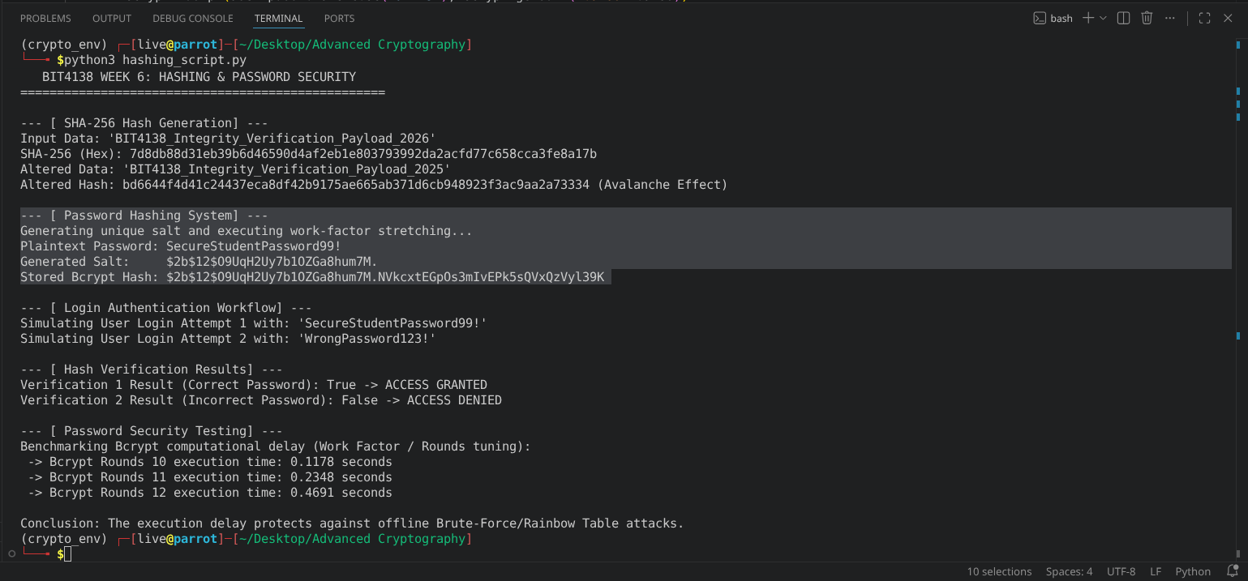

Fig 3: Login Authentication Workflow
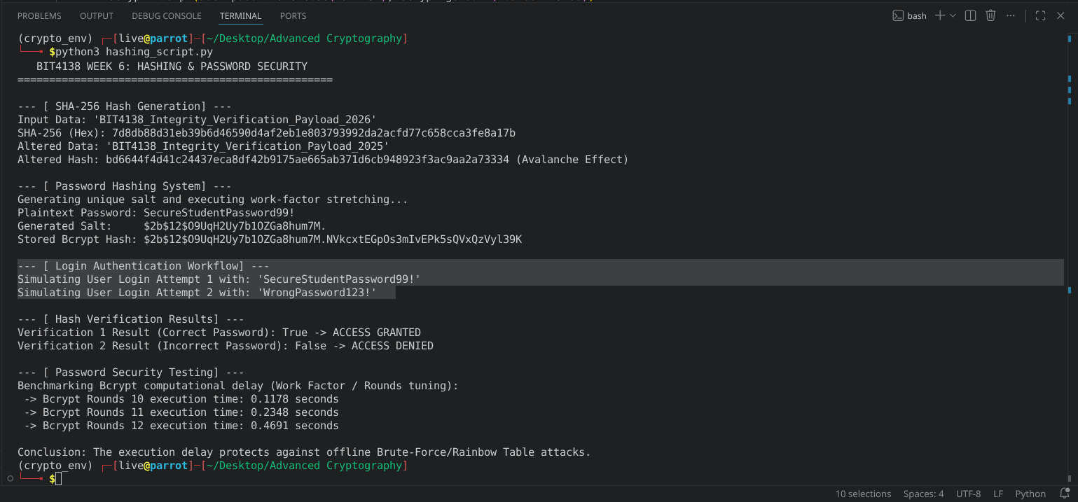

Fig 4: Hash Verification Results
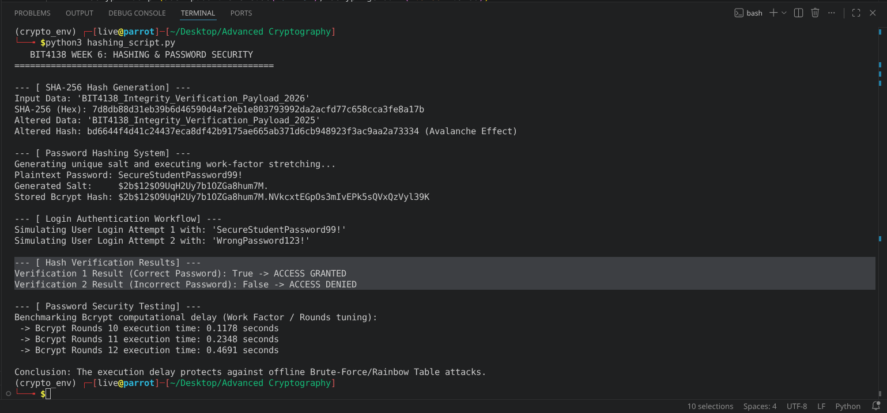

Fig 5: Password Security Testing
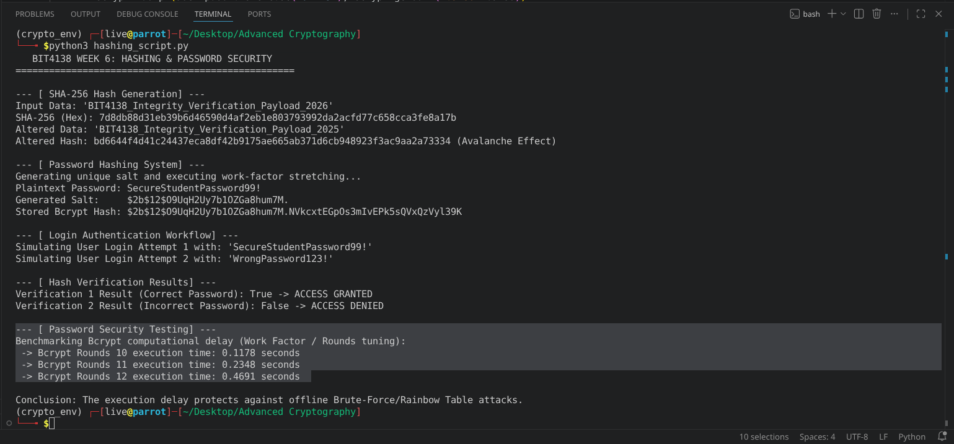

Creative Task: Password Strength Analyzer and Leak Simulator

Fig 1: Password Entropy and Failure Mode
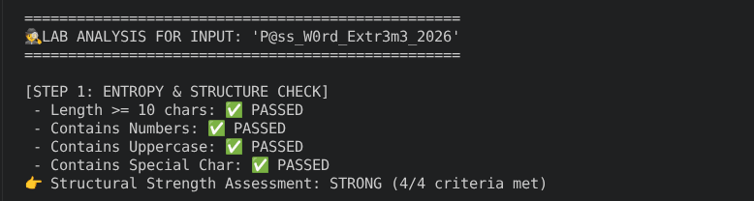

Fig 2: Simulated Breach / Rainbow Table Match

Fig 3: Secure Cryptographic Isolation

Student Reflection
Evaluated SHA-256 data integrity tracking and implemented a resilient password storage system using bcrypt. I explored how salting neutralizes precomputed rainbow table vector threats while algorithmic stretching stops brute-force tools. Mitigating type errors during byte-string formatting proved challenging, but the metrics validated how computational latency properly defends user credentials.

Week 7: Digital Signatures and Certificates
Digital Signature Implementation and Certificate Management

Fig 1: Digital Signature Generation
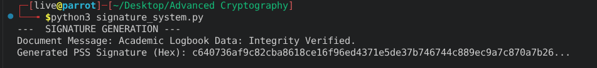

Fig 2: Signature Verification Process
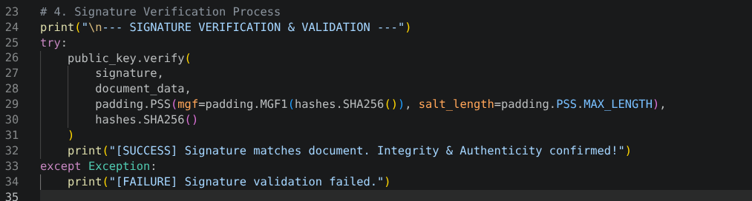

Fig 3: Certificate Creation Using OpenSSL
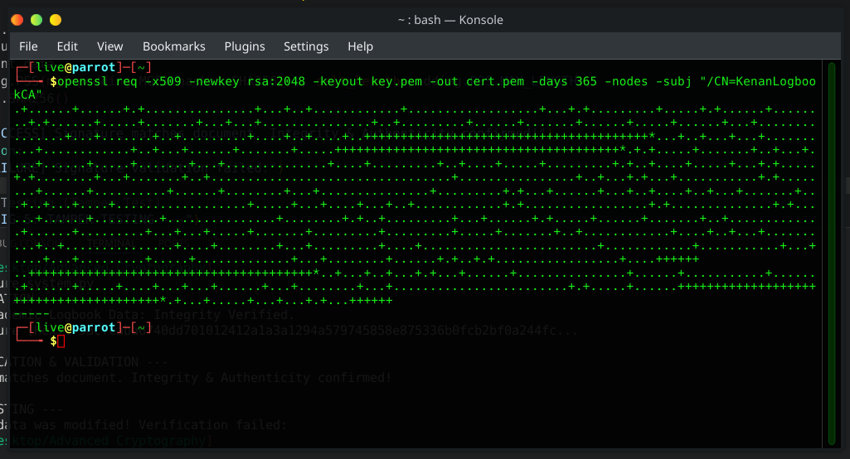

Fig 4: Secure Document Validation

Fig 5: Certificate Testing Results
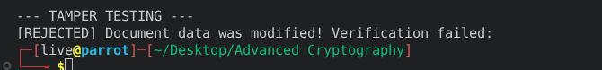

Creative Task: Software Update Integrity Guard

Fig 1: Cryptographic Packaging and Core Signing Execution
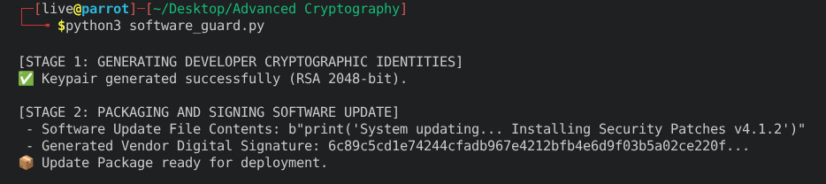

Fig 2: Client Verification Success & Deployment Authorization
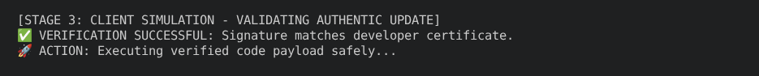

Fig 3: Malicious Interception and Tamper Defiance
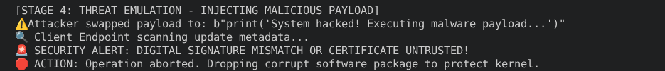

Student Reflection
Digital signatures guarantee non-repudiation and data integrity. The authentication workflow binds a public key to an identity via certificates. Validation checks validity periods and cryptographic signatures against trusted roots. Real-world applications include secure e-commerce, software distribution signing, code signing, and securing HTTPS communications using SSL/TLS infrastructure globally.

